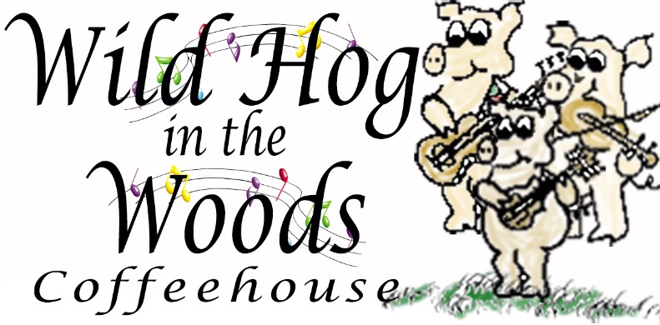
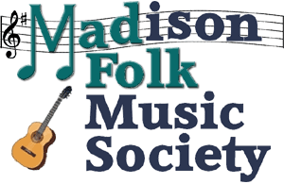

PRESS RELEASE
Wild Hog in the Woods and Madison Folk Music Society opens fall concert season with award-winning Irish Folk Singer/Songwriter Aoife Scott, August 14

Contact: Jamie Diana Poindexter  Phone: (608) 770-8092 (leave a message if not answered)  Email: jamiep@wildhoginthewoods.org | FOR IMMEDIATE RELEASE  July 23, 2019

Madison, Wisconsin - The Wild Hog in the Woods Coffeehouse and Madison Folk Music Society announce that Aoife Scott, an award -winning singer and songwriter from Dublin Ireland, will perform in concert on Wednesday, August 14, 2019.

Special Location: 931 East Main St. (entrance on Brearly Street), Madison, Wisconsin.
Time: Doors open at 7:00 PM, concert begins 7:30 PM.
Admission at the door: $20 donation (no advanced tickets). Proceeds to benefit the Wil-Mar Neighborhood Center’s remodeling capital campaign.
*NOTE: 931 E. Main is the temporary location of the Williamson/Marquette (Wil-Mar) Neighborhood Center during remodeling of their regular location on Jenifer Street. Free parking lot just south of the building. The Capital City Trail is a block away as it runs through McPike Park. If using Madison Metro there are many bus routes to choose from with bus stop on East Washington Ave. Use their trip planner at https://www.cityofmadison.com/metro

PreSS KIT available
This press release and selection of high resolution photos, posters and more: wildhoginthewoods.org/PressReleases

ABOUT AOIFE SCOTT

Aoife Scott is a daughter of the legendary Black Family, one of the most important musical clans in Ireland. Aoife is rising to the top of the traditional and folk music scene by her own right, in Ireland, the U.S. and the world.

Fragile and ethereal one minute and strong and vibrant the next, Aoife has a dynamic and profound voice, which explores the emotional depths of her lyrics, leaving the audience entranced. Her music has a broad creative scope but is largely influenced by her own roots in folk and traditional Irish music.

Aoife is a true veteran of the Irish and Folk Festival circuit, having performed and headlined at dozens of festivals and venues around the globe and the Midwest, including Milwaukee’s Irish Fest and in Madison the past two years.

Her accolades include being named Best Folk Act at the Irish Post Music Awards, beating stiff competition in the category with the legendary Christy Moore, Dublin folk band Lankum as well as Limerick singer Emma Langford. She also claimed the award of Emerging Artist of the Year at the Live Ireland Awards in June 2018.

In 2019, her most recent song “The December Letter” won Single of the Year at the ALSR Celtic Music Awards (US) and was the most played Christmas song on RTE Radio 1 in December 2018.

Aoife’s single “All Along the Wild Atlantic Way” also hit the number 1 slot, knocking Ed Sheeran off the top spot and was named “Song of the Year” at the Irish Folk Music Awards in 2017. Aoife describes this song as her “love letter to the West of Ireland, a place where my heart lies”.
Aoife’s debut album, “Carry the Day”, was reviewed with resounding praise. The Irish Times quoted it as a “richly layered impressive debut album”. Folk World (EU) hailed her for “her beautiful crystal-clear warm vocals. Stylistically she successfully bridges Irish trad, contemporary singer songwriter and Pop”. The Irish Echo (US) described it as “an important instalment in the legacy of traditional Irish music”.

Following the success of her debut album, in October Aoife will be releasing her first single from her next album, “HomeBird”, which is scheduled to be released in January 2020.

Find out more about Aoife Scott:
www.aoifescott.com
www.facebook.com/aoifescottmusic
www.twitter.com/aoifescott
www.irishpost.com/news/aoife-scott-wins-best-irish-folk-act-at-the-irish-post-music-awards-155761

On the air at wort fm
Aoife will be on the air at 11 AM that morning on Madison’s community radio station, WORT FM 89.9 and wortfm.org, during the “Back to the Country” show with Bill Malone.

About the Wild Hog in the Woods Coffeehouse
The Wild Hog in the Woods (“the Hog”) operates a 60’s style coffeehouse with live folk music and other special events, workshops, dances, sometimes in cooperation with other organizations. The Hog is a membership organization, a 503(c)3 not for profit based on cooperative principles that was started by musicians in 1978 when there were not many venues at which to play their music. Members play an important role in the Wild Hog, volunteering their time to host the coffeehouse and other events, including promotion, booking performers, running sound, baking, newsletter and web site, and much more. We always welcome new members!

Web site: www.wildhoginthewoods.org

About the MADISON FOLK MUSIC SOCIETY
Madison Folk Music Society ("Mad Folk") is a 503(c)3 non-profit society dedicated to fostering folk/acoustic music in the greater Madison, Wisconsin area. Revenues are derived solely from memberships and concert ticket sales, plus special gifts from members and others. Mad Folk presents six to 10 concerts each year featuring some of folk music’s finest national touring acts and often sponsors stages at local festivals and hosts outdoor concerts and sing-alongs.

Web site: www.madfolk.org

-End-

